**Position**

* Create a page containing a paragraph followed by three images
* Add more paragraphs after the images in order to make the page scrollable
* **Relative**
  + The first image should be positioned relatively
  + Move the image 50px from the top and 100px from the left
  + If image is over the text of the paragraph, add margin to the bottom of the image
* **Absolute**
  + The second image should be positioned absolutely and it should appear 10px from the right and 15px from the top of the edge of the browser window
  + Position the third image at the bottom of the page
* **Fixed**
  + Add a link at the bottom of the page
  + The link should bring you back to the top of the page
  + Position the link in the bottom right corner of the window
  + The link’s position should be fixed so that is always visible

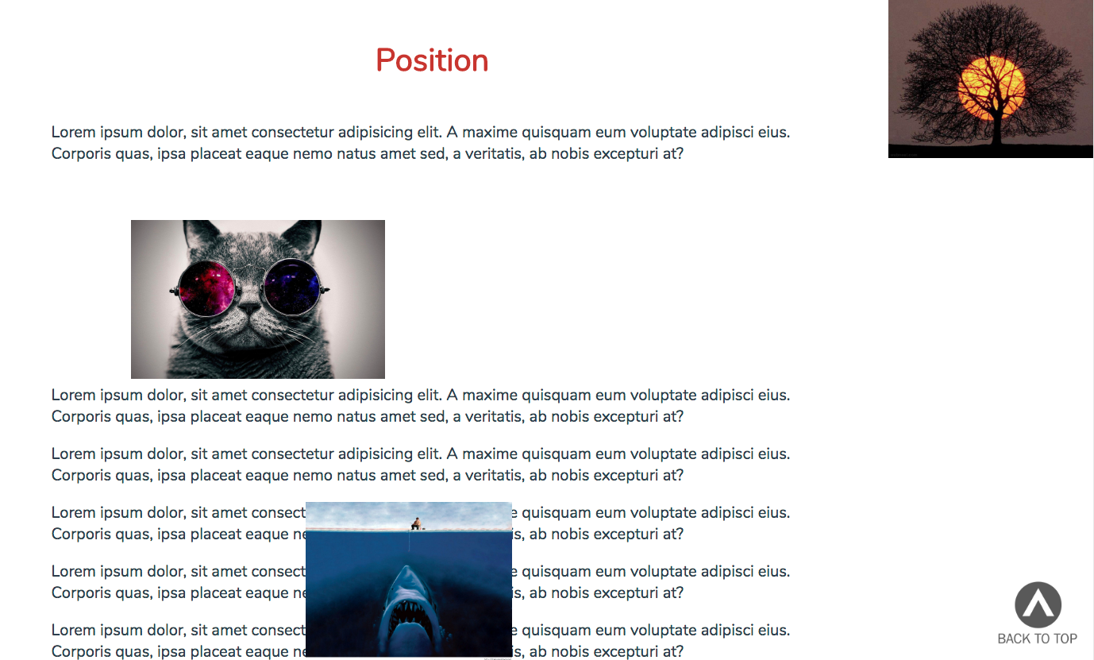

**Advanced positioning (Homework)**

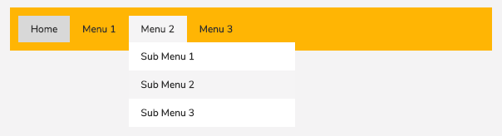

**Z-Index**

* **Creating divs**
  + Create a page with three divs
  + Elements on the page should be 200px wide and 200px high
  + Each div should be of different color
  + Divs should be stacked one on top of the other
* **Arranging divs**
  + Copy code from the first section and create a new one
  + Position divs as presented in the example
  + Use relative position for positioning
* **Rearranging divs and stacking order**
  + Create one more section using html code from the first section
  + Arrange divs as shown in the example
  + This time use absolute positioning
* **Change stacking order using z-index**

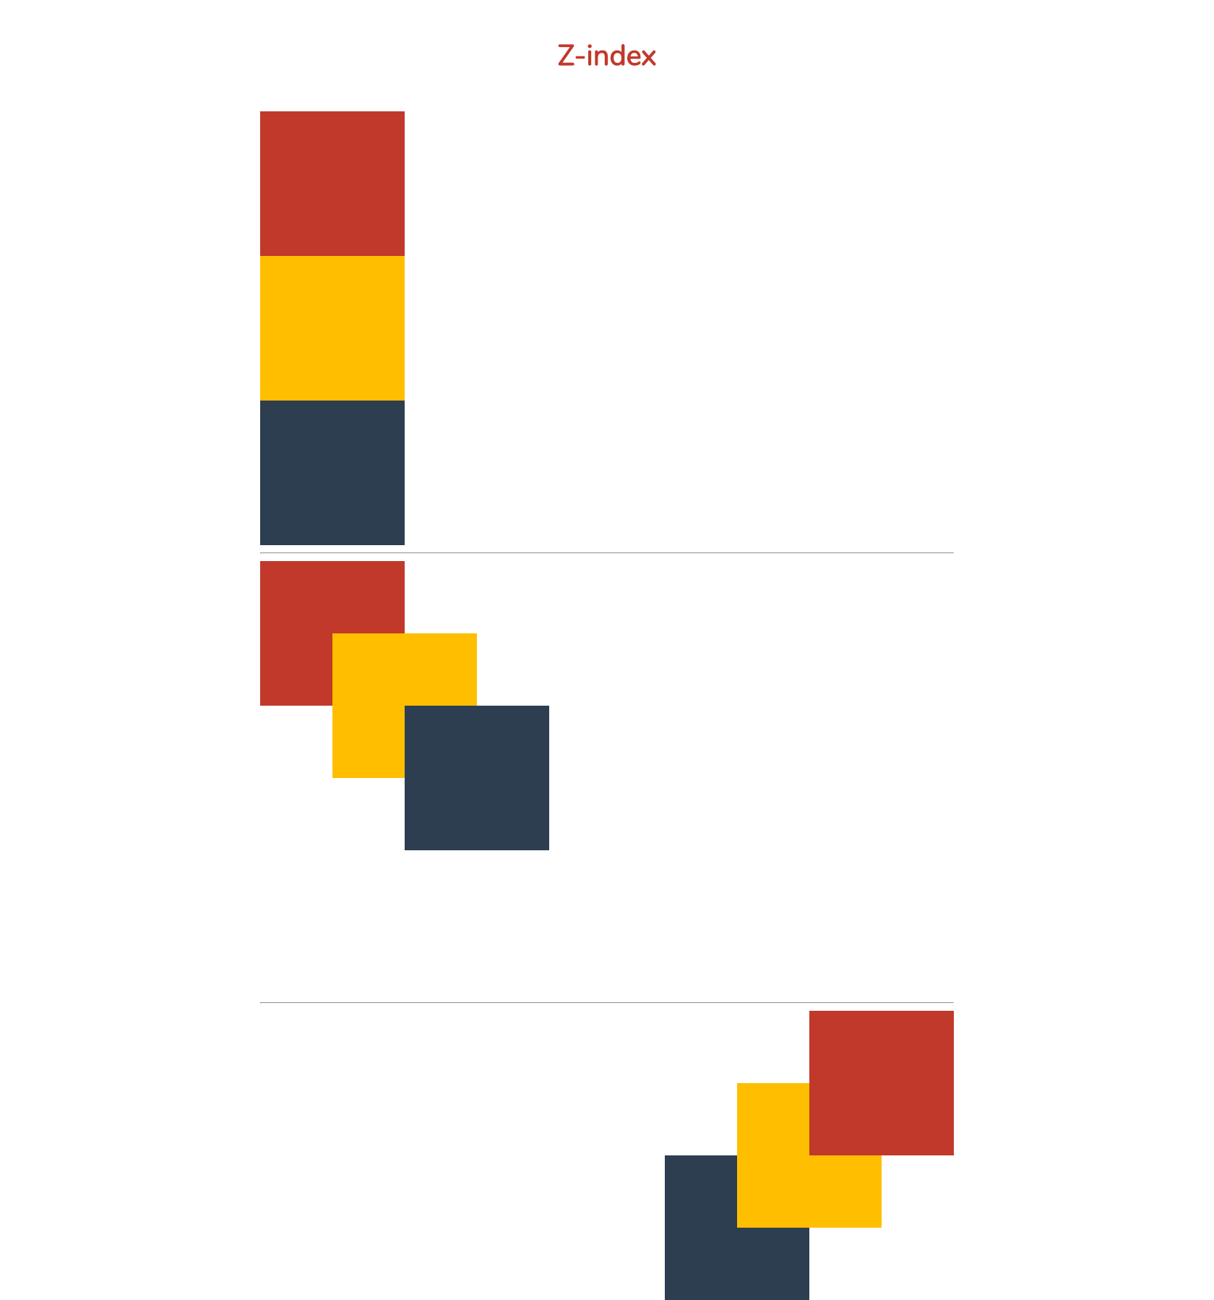

**Float**

* **Create navigation**
  + Navigation should be implemented as unordered list
  + Transform navigation using CSS to be in one line
  + Navigation is floated to the right
  + Width of navigation container is 960px



* **Recreate the following layout** (on the next page)

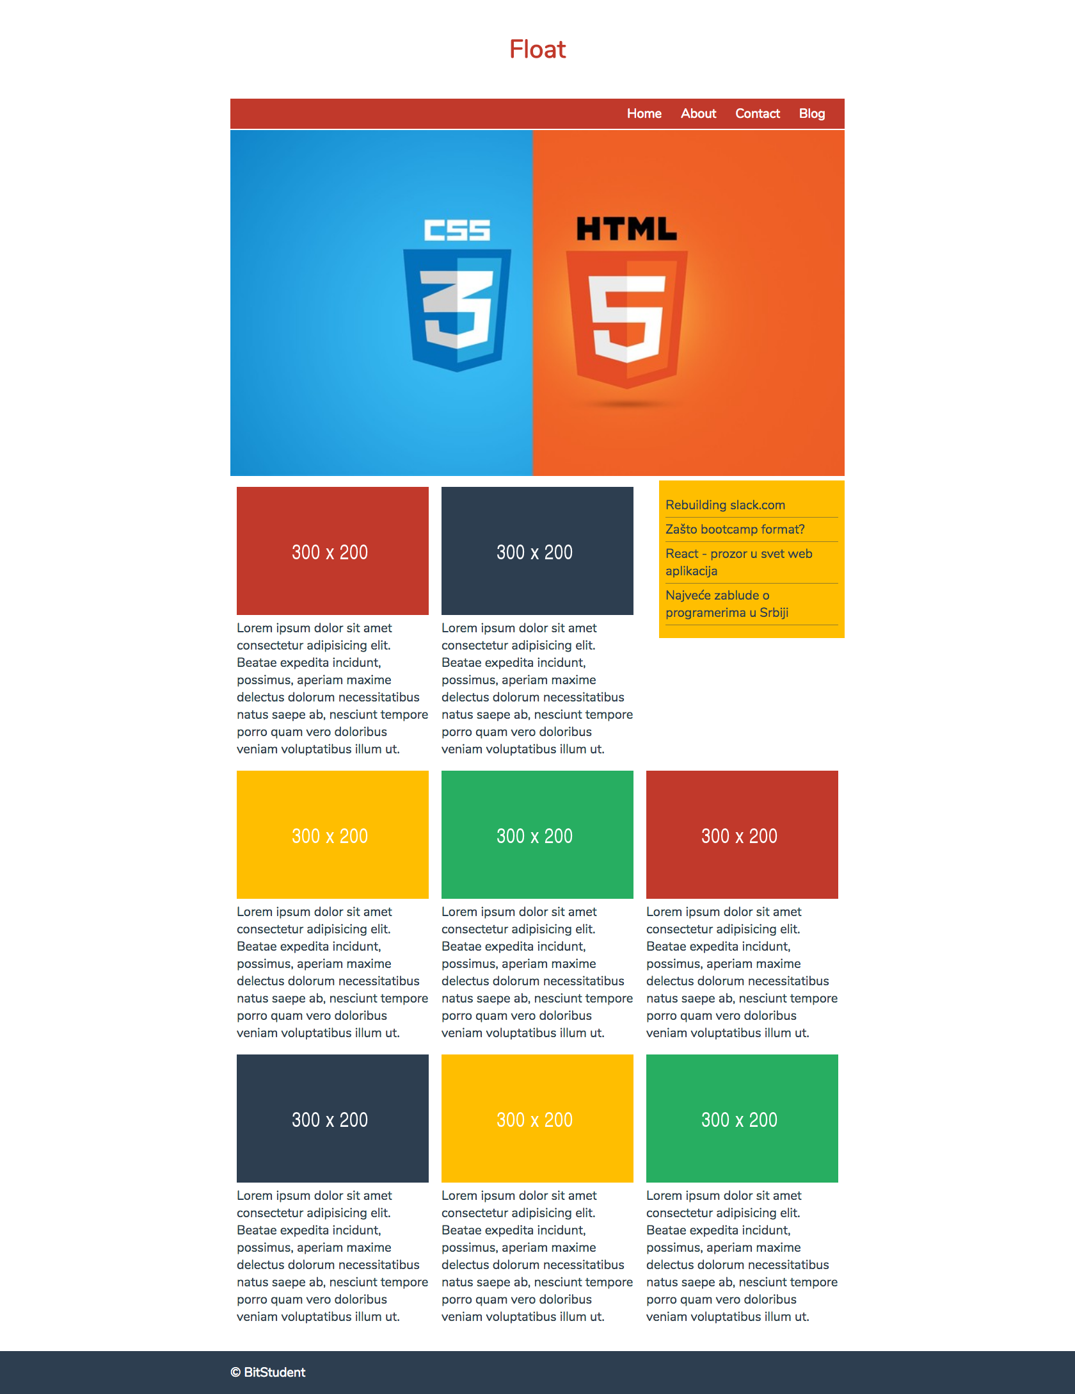

Recourses:

<https://udemy-images.udemy.com/course/750x422/505208_2307_4.jpg>

<http://via.placeholder.com/300x200>